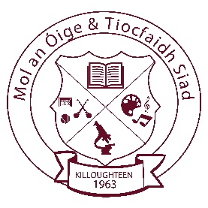
Killoughteen National School
Killoughteen, Newcastle West, Co. Limerick. Roll number: 18708U
e-mail: killoughteennationalschool@eircom.net Tel: (069)61195 Web: killoughteenns.com

06/06/2019

Dear Parents,
Our school tracksuit supplier has increased their prices since last year.
Tracksuits can be ordered directly through the school.
To facilitate a school group order for next year I intend to send out an e-payment request on the Aladdin app. The Parents’ Association will provide sizing opportunities for you if required. Please let us know via email.
Prices will be:

Tops: €20
Pants: €15
Full Set: €35
For later additional purchases you will also place your order through the school directly. A stock of tracksuits will be maintained in the school throughout the year to help ensure delays are avoided when tracksuits are needed. It is however best if you place your initial order in June to ensure delivery for September.

Le Meas,
Mr Curtin and Parents’ Association

