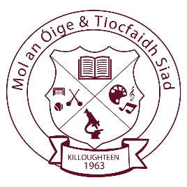
KILLOUGHTEEN N.S.
Killoughteen, Newcastle West, Co. Limerick. Tel: (069)61195
Email: killoughteennationalschool@eircom.net Website: www.killoughteenns.com

Senior Infant Book List 2019 – 2020
Teacher: Ms C. Ryan

English: Go With the Flow B (CJ Fallon)
Jolly Phonics Pupil Book 2 Precursive (Colour Edition)
Jolly Phonics Pupil Book 3 Precursive (Colour Edition)
Just Phonics Senior Infants (Educate.ie)

Gaeilge: Bua na Cainte B (Edco)

Maths: Busy at Maths Senior Infants (C.J. Fallon)

Religion: Grow in Love Senior Infants (Veritas)

S.E.S.E: Explore with Me Senior Infants (EDCO)

(Please mark your child’s name clearly on the front cover of all books)

Other: Pencil Case including Pencil, Crayons & Rubber

1 x A4 Document Zip Wallet (Plastic)
1 x A4 Document Wallet (Paper)

Copies: €5 (please send into school in an envelope with your child’s name on it)
------------------------------------------------------------------------------------------------------------

School contribution €30 per pupil. (payment link via Aladdin)
This will cover the cost of Aladdin app to aid school communication – (text messages, absence explanations, updating phone details, homework), photocopying, art and craft, 24-hour Pupil Personal Accident Insurance.

Please label all removable clothing, coats, jumpers, hats etc.

Please note: If you wish to speak to your child’s teacher, please ring the office to make an appointment.

