14/06/2019

Dear Parent(s),

I would like to inform you of progress regarding our next new build at Killoughteen NS. We are now building two ASD classes instead of one as originally stated. A second class was requested by the schools Special Education Needs Organiser and this has been approved by the Department of Education. We are therefore now at the design stage for adding this second class.

Our school hall will be built in conjunction with this build. The fundraising for this hall is being exceptionally well supported. We have just surpassed the figure of €20,000.

I will inform you of progress made after the summer break.

Le Meas

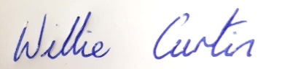
Willie Curtin

