12/05/2020
Dear Parent(s),

I hope everyone is doing okay at the moment. Following on from recent HSE and government guidelines, we are preparing for re-opening of schools next September.

I will be sending out booklists this week. Due to the poll received that over 95% of families would like to get books at the school we will engage the services of Domhnall O Gairbhi to complete this service.

Please READ this CAREFULLY BEFORE filling in your order form.

The booklists attached are on an Excel template. When you open the Excel order form, please do the following to make sure that there are no errors;

- Enter your child’s name. (top of the form)
- Place an X next to each book required. (column C)
- Place an X also in the next column (column D) if you wish to get the book covered. Each book costs €1 to get it covered PLEASE NOTE DO NOT PUT AN X IN COLUMN D for STATIONERY. (COPIES PENCILS RUBBERS will NOT BE COVERED!)
- The total for books, stationery, and covering is automatically calculated.
- When completed, save the form and return it via email to info@killoughteenns.com.
- An epayment will be created on Aladdin. You can enter the amount due and pay online. You will know the total amount due after filling in your order form. This must be completed by June 20th. Books and stationery can be collected in August. This date will be confirmed later.

If you have any questions, please don’t hesitate to contact the school (via email preferably.)

Le Meas

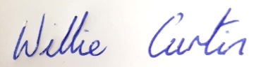
Willie Curtin

Please see next page

Dear Parent(s),
Domhnall also supplies school bags and lunch boxes & drink bottles.
He usually sells a lot of these at the pop-up shops. However, as we will not have this opportunity this year due to COVID 19, I am placing some information on them here and you can add to your order if you wish. See some information received from Domhnall below.

‘The Totto wheelie bags have a 5-year guarantee and are very good quality. I have never had one returned and students usually get great value out of them.
Smash products such as reusable BPA free plastic bottles and lunch boxes are also extremely popular each year.
For older students (5th and 6th class) a lot tend to purchase the large JanSport school bags. These bags have a lifetime guarantee and more often than not see these pupils through second level.’

I have attached some pictures of these for your information and you can purchase these at the school if you wish when collecting the school books and stationery. We will have a limited supply available.

Thank You.
Mr Curtin

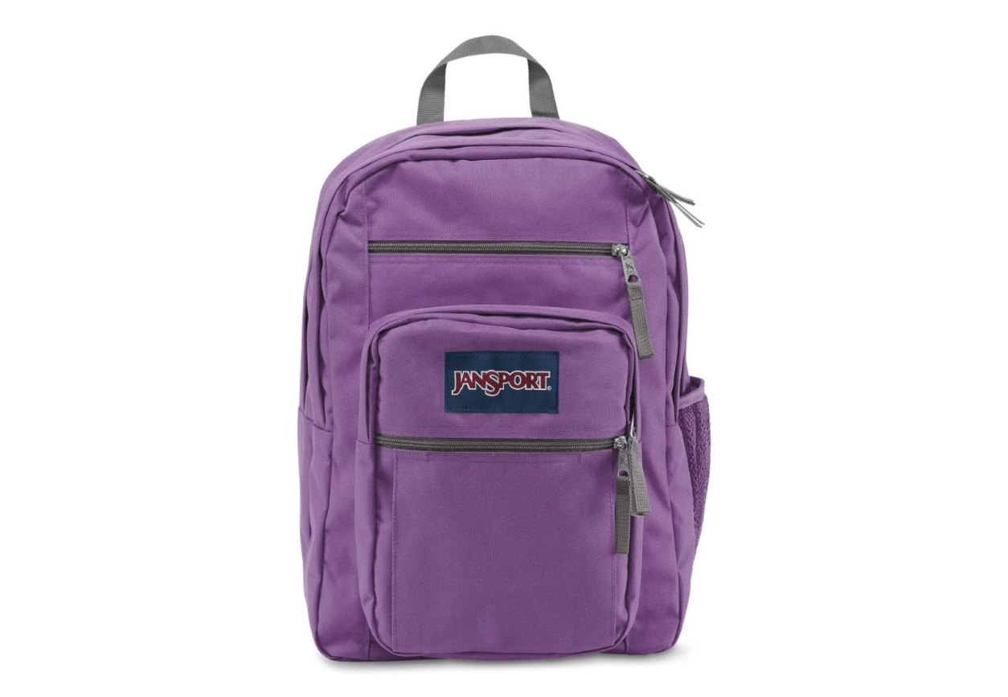
Jan Sport School Bag
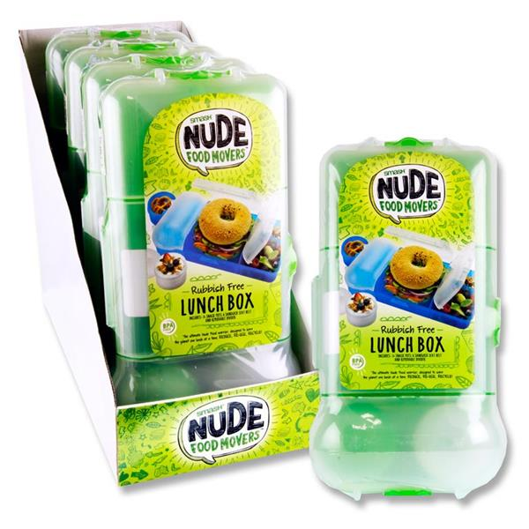Lunchboxes

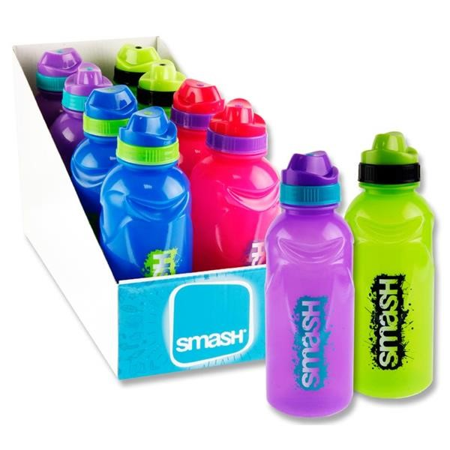
Drinks Bottles

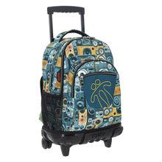

Totto Wheelie bags

