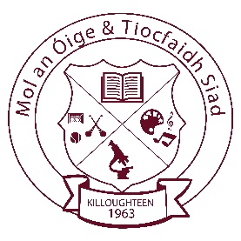
Killoughteen National School
Killoughteen, Newcastle West, Co. Limerick. Roll number: 18708U
e-mail: info@killoughteenns.com Tel: (069)61195 Web: killoughteenns.com

07/05/2020

Dear Parents,
Our school tracksuit supplier has kept their prices the same as last year.
Tracksuits can be ordered directly through the school. I have ordered a stock of tracksuits and these will be available for collection at the school in August. When we have an exact date, we will let you know.
Prices will be:

Tops: €20
Pants: €15
Full Set: €35
For later additional purchases you will also place your order through the school directly. A stock of tracksuits will be maintained in the school throughout the year to help ensure delays are avoided when tracksuits are needed.

Le Meas,
Mr Curtin and Parents’ Association

