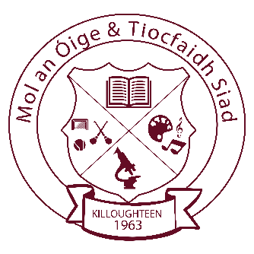
Killoughteen National School
ANNUAL ADMISSION NOTICE
in respect of admissions to the 2022/2023 school year

Admission Policy and Application Form
A copy of the school’s Admission Policy and the Application Form for Admission for the 2022/2023 school year is available as follows: –
To download at: www.killoughteennns.com
On request: By emailing info@killoughteenns.com or writing to: Killoughteen NS, Killoughteen, Newcastle West, Co. Limerick.

PART 1 - Admissions to the 2022/2023 school year

Application and Decision Dates for admission to Killoughteen National School for the school year 2022 / 2023
The following are the dates applicable for admission to Junior Infants

The school will commence accepting applications for admission on | 1st October 2021
The school shall cease accepting applications for admission on  (Please note – An applicant must be at least 4 years of age on the first day of the school year for which s/he is seeking enrolment. However, the B.O.M. recommends that applicants are at least 4 years of age on or before the 1st of March in the calendar year of the proposed enrolment. | 31st October 2021
The initial date by which applicants will be notified of the decision on their application is | 30th November 2021
The period within which applicants must confirm acceptance of an offer of admission is | 15th December 2021
*Failure to accept an offer within the prescribed period above may result in the offer being withdrawn

Note: the school will consider and issue decisions on late applications in accordance with the school’s admission policy.

Special Class Application and Decision Dates for admission to Killoughteen National School for the school year 2022/2023
The following are the dates applicable for admission to the school’s Special Class which caters exclusively for children [diagnosed with (ASD) Autistic Spectrum Disorder in accordance with DSM V or ICD10)] -
The school will commence accepting applications for admission to the special class on | 1st October 2021
The school shall cease accepting applications for admission to the special class on | 31st October 2021
The date by which applicants will be notified of the decision on their application for admission to the special class is | 30th November 2021
The period within which applicants must confirm acceptance of an offer of admission is | 15th December 2021

*Failure to accept an offer within the prescribed period above may result in the offer being withdrawn

Number of places being made available in 2022/ 2023

The number of places being made available in junior infants is | 28
The number of places being made available in the special class* catering for children with ASD (Autistic Spectrum Disorder) is | 6

